**Test Case** **0041**

**System:** VirtuCardsHost

**Description:** Test whether backgrounds can be changed on the host application

**Severity:** 2

**Instructions**

**Test 1**

1. Start VirtuCardClient application
2. Click the button labeled “Sign In”
3. Enter “virtucards01@gmail.com” into the text input labeled “Enter email…”
4. Enter “Testing1” into the text input labeled “Enter password…”
5. Press the button labeled “Login”
6. A window should appear saying “Login Success”
7. Press the OK button that appears on that window
8. Start VirtuCardHost application
9. Repeat steps 2-7 but on the VirtuCardHost application, but use “virtucards02@gmail.com” as the email and use “Testing1” as the password
10. Select the “GoFish” option from the game choices dropdown
11. The checkbox “Allow host to Join” should be checked on the host
12. Press the Create Game button
13. On the VirtuCardClient application enter the 6-character room code found on the host’s screen into the field labeled “Enter Code…”
14. Press the Join Game button on the client
15. Start another VirtuCardClient application
16. Repeat steps 2-7 on the new VirtuCardClient application, but use “virtucards02@gmail.com” as the email and use “Testing1” as the password
17. After both players have joined, press the start game button on the VirtuCardHost application.
18. On the host application, press the settings button on the left side of the screen.

**Expected Result:** There is Change Background and Default Background available on the settings panel. The Default Background cannot be clicked.

**VirtuCard Host:**

Change background button

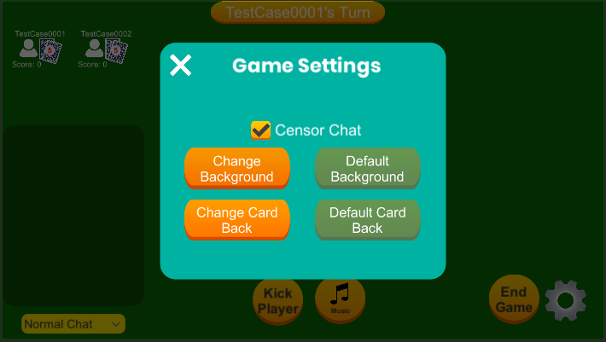

**Test 2**

1. Start VirtuCardClient application
2. Click the button labeled “Sign In”
3. Enter “virtucards01@gmail.com” into the text input labeled “Enter email…”
4. Enter “Testing1” into the text input labeled “Enter password…”
5. Press the button labeled “Login”
6. A window should appear saying “Login Success”
7. Press the OK button that appears on that window
8. Start VirtuCardHost application
9. Repeat steps 2-7 but on the VirtuCardHost application, but use “virtucards02@gmail.com” as the email and use “Testing1” as the password
10. Select the “GoFish” option from the game choices dropdown
11. The checkbox “Allow host to Join” should be checked on the host
12. Press the Create Game button
13. On the VirtuCardClient application enter the 6-character room code found on the host’s screen into the field labeled “Enter Code…”
14. Press the Join Game button on the client
15. Start another VirtuCardClient application
16. Repeat steps 2-7 on the new VirtuCardClient application, but use “virtucards02@gmail.com” as the email and use “Testing1” as the password
17. After both players have joined, press the start game button on the VirtuCardHost application.
18. On the host application, press the settings button on the left side of the screen.
19. This brings up the settings panel. Press the Change Background button.

**Expected Result:** There is a File Explorer window allowing the user to select their custom background for the host

**VirtuCard Host:**

File explorer panel available:

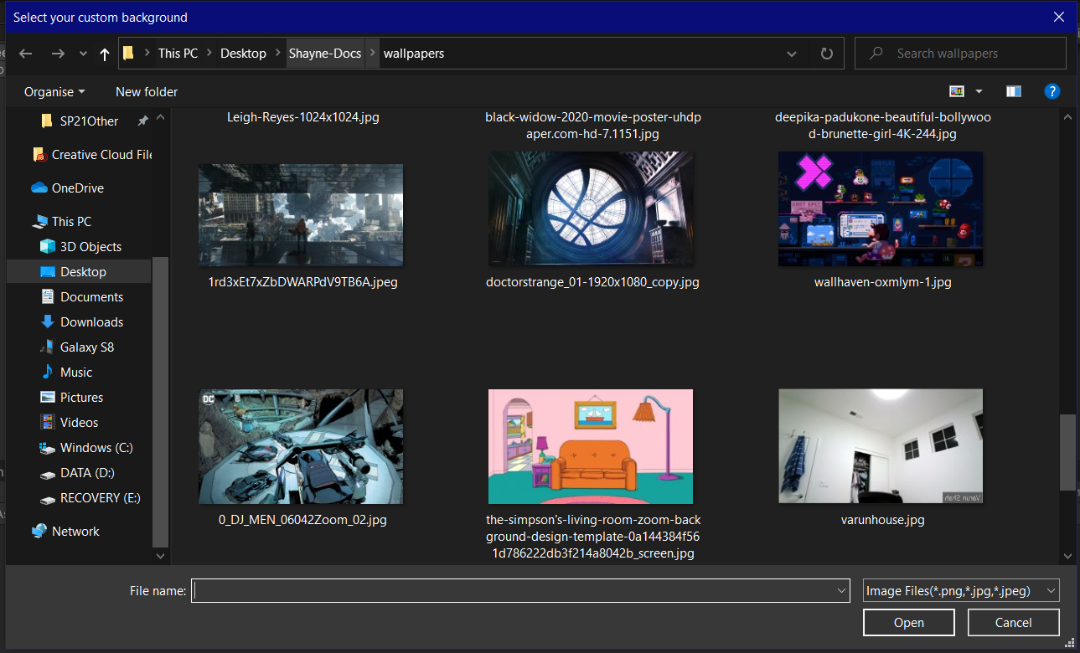

**Test 3**

1. Start VirtuCardClient application
2. Click the button labeled “Sign In”
3. Enter “virtucards01@gmail.com” into the text input labeled “Enter email…”
4. Enter “Testing1” into the text input labeled “Enter password…”
5. Press the button labeled “Login”
6. A window should appear saying “Login Success”
7. Press the OK button that appears on that window
8. Start VirtuCardHost application
9. Repeat steps 2-7 but on the VirtuCardHost application, but use “virtucards02@gmail.com” as the email and use “Testing1” as the password
10. Select the “GoFish” option from the game choices dropdown
11. The checkbox “Allow host to Join” should be checked on the host
12. Press the Create Game button
13. On the VirtuCardClient application enter the 6-character room code found on the host’s screen into the field labeled “Enter Code…”
14. Press the Join Game button on the client
15. Start another VirtuCardClient application
16. Repeat steps 2-7 on the new VirtuCardClient application, but use “virtucards02@gmail.com” as the email and use “Testing1” as the password
17. After both players have joined, press the start game button on the VirtuCardHost application.
18. On the host application, press the settings button on the left side of the screen.
19. This brings up the settings panel, press the change background button.
20. Select a background of your choice from your device.

**Expected Result:** The background changes on the host to the selected background.

**VirtuCard Host:**

Change background button



Background changed from default green background to custom background.

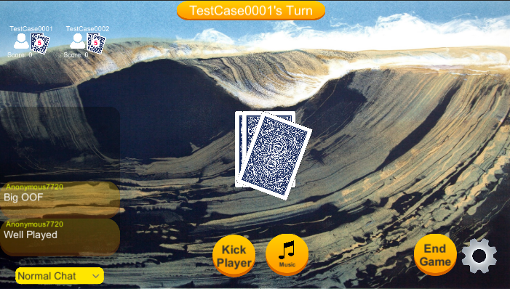

**Test 4**

1. Start VirtuCardClient application
2. Click the button labeled “Sign In”
3. Enter “virtucards01@gmail.com” into the text input labeled “Enter email…”
4. Enter “Testing1” into the text input labeled “Enter password…”
5. Press the button labeled “Login”
6. A window should appear saying “Login Success”
7. Press the OK button that appears on that window
8. Start VirtuCardHost application
9. Repeat steps 2-7 but on the VirtuCardHost application, but use “virtucards02@gmail.com” as the email and use “Testing1” as the password
10. Select the “GoFish” option from the game choices dropdown
11. The checkbox “Allow host to Join” should be checked on the host
12. Press the Create Game button
13. On the VirtuCardClient application enter the 6-character room code found on the host’s screen into the field labeled “Enter Code…”
14. Press the Join Game button on the client
15. Start another VirtuCardClient application
16. Repeat steps 2-7 on the new VirtuCardClient application, but use “virtucards02@gmail.com” as the email and use “Testing1” as the password
17. After both players have joined, press the start game button on the VirtuCardHost application.
18. On the host application, press the settings button on the left side of the screen.
19. This brings up the settings panel, press the Default background button.

**Expected Result:** The background changes on the host from a custom background to the default (green) background.

**VirtuCard Host:**

Default background button

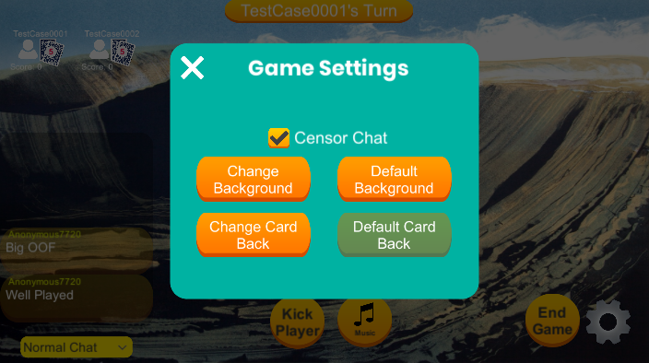

Custom background changed to default background:

